This documentation is related to Build the Android kernel for marshmallow.
- First we need to get source code
STEP 1 :
Installing Repo:
=>create a bin directory in home
mkdir ~/bin
=>set the bin in your path.
PATH=~/bin:$PATH
=>Download repo python script from below link.
curl https://storage.googleapis.com/git-repo-downloads/repo > ~/bin/repo
=>Give executable permission for that repo script.
chmod a+x ~/bin/repo
Initializing a Repo client:
=>Create a empty directory for android
mkdir WORKING_DIRECTORY
cd WORKING_DIRECTORY
=>Configure the git with name and mail ID
git config --global user.name "Your Name"
git config --global user.email "you@example.com"
=>Run repo init to bring down the latest version of Repo with all its most recent bug fixes.
repo init -u https://android.googlesource.com/platform/manifest
Downloading the Android Source Tree:
=>run sync command to download the source code.
repo sync

STEP 2:
BUILD
==> Setup environment.
source build/envsetup.sh
==>Choose a Target.
lunch aosp_arm-eng
==>Build the code.
make -j4(Here there will be a chance of make errors we should resolve those. Ex: We should add the bootanimation.zip file in Required path)

Another way of Download the source code and building
We can run the script named as “DB410c_build.sh”
source code of the scrip is given below :

#!/bin/bash

#Copyright © 2015, Qualcomm Innovation Center, Inc. All rights reserved. Confidential and proprietary.
ITCVER="6.0.1_Marsh_Mallo_P2"
WORKDIR=`pwd`
BUILDROOT="$WORKDIR/APQ8016_410C_LA.BR.1.2.7-01010-8x16.0_$ITCVER"
PATCH_DIR="$WORKDIR/PATCH_8x16_410c_LA.BR.1.2.7-01010-8x16.0"
CAFTAG="LA.BR.1.2.7-01010-8x16.0.xml"

function SBC410C_SOURCE_CODE() {
# Do repo sanity test
if [ $? -eq 0 ]
then
echo "Downloading code please wait.."
repo init -u git://codeaurora.org/platform/manifest.git -b release -m ${CAFTAG} --repo-url=git://codeaurora.org/tools/repo.git
repo sync -j20
repo forall -c "git checkout -b master"
repo forall -c "git checkout -b LA.BR.1.2.7-01010-8x16"
else
echo "repo tool problem, make sure you have set up your build environment"
echo "1) http://source.android.com/source/initializing.html"
echo "2) http://source.android.com/source/downloading.html (Installing Repo Section Only)"
exit -1
fi
}

# Function to autoapply patches to CAF code
Apply_android_patches()
{ cd $WORKDIR
wget https://www.codeaurora.org/patches/quic/la/PATCH_8x16_410c_LA.BR.1.2.7-01010-8x16.0.tar.gz
tar -xvzf PATCH_8x16_410c_LA.BR.1.2.7-01010-8x16.0.tar.gz
cd $BUILDROOT
echo "Applying patches ..."
if [ ! -e $PATCH_DIR ]
then
echo -e "$PATCH_DIR : Not Found "
fi
cd $PATCH_DIR
patch_root_dir="$PATCH_DIR"
android_patch_list=$(find . -type f -name "*.patch" | sort) &&
for android_patch in $android_patch_list; do
android_project=$(dirname $android_patch)
echo -e "applying patches on $android_project ... "
cd $BUILDROOT/$android_project
if [ $? -ne 0 ]; then
echo -e "$android_project does not exist in BUILDROOT:$BUILDROOT "
exit 1
fi
git am $patch_root_dir/$android_patch
done
}

# Function to check whether host utilities exists
check_program() {
for cmd in "$@"
do
which ${cmd} > /dev/null 2>&1
if [ $? -ne 0 ]
then
echo
echo -e "Cannot find command \"${cmd}\" "
echo
exit 1
fi
done
}

#Main Script starts here
#Note: Check necessary program for installation
echo
echo -e "$QUALCOMM_410C_SBC Release Version : $ITCVER "
echo -e "$QUALCOMM_410C_SBC Workdir : $WORKDIR "
echo -e "$QUALCOMM_410C_SBC Build Root : $BUILDROOT "
echo -e "$QUALCOMM_410C_SBC Patch Dir : $PATCH_DIR "
echo -e "$QUALCOMM_410C_SBC Codeaurora TAG : $CAFTAG "
echo -n "Checking necessary program for installation......"
echo
check_program tar repo git patch
if [ -e $BUILDROOT ]
then
cd $BUILDROOT
else
mkdir $BUILDROOT
cd $BUILDROOT
fi

#1 Download code
SBC410C_SOURCE_CODE
cd $BUILDROOT
#2 Apply APQ8016 410C Snapdragon Dragonboard patches
Apply_android_patches
cd $BUILDROOT
echo -e " Extracting proprietary binary package to $BUILDROOT ... "
tar -xzvf ../proprietary_LA.BR.1.2.7-01010-8x16.0_410C_May.tgz -C vendor/qcom/
mv vendor/qcom/proprietary/bootanimation.zip device/qcom/msm8916_64/
mv vendor/qcom/proprietary/WCNSS_qcom_wlan_nv.bin device/qcom/msm8916_64/

cd $BUILDROOT
#3 Build
#source build/envsetup.sh
#lunch msm8916_64-userdebug
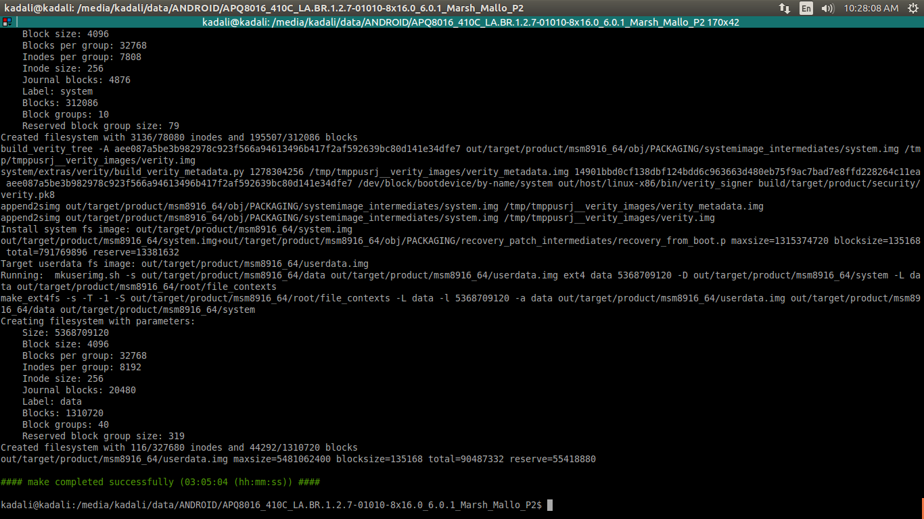
#make -j10 | tee log.txt

After compiling the source code We need to flash into the device:
step1: Check the image is created or not
PATH: /media/kadali/data/ANDROID/APQ8016_410C_LA.BR.1.2.7-01010-8x16.0_6.0.1_Marsh_Mallo_P2/out/target/product/msm8916_64$
There will be 6 images
1)boot.img
2)userdata.img
3)cache.img
4)recovery.img
5)persist.img
6)system.img
if we have all these images we are ready to flash those.
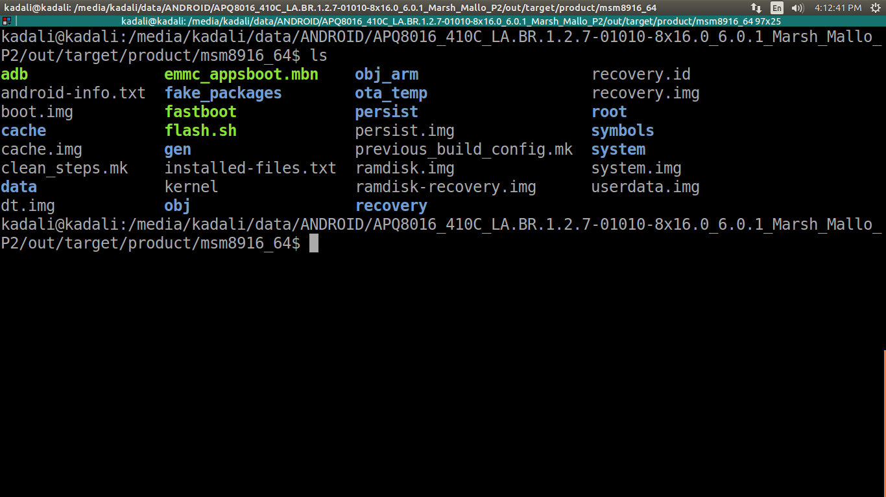

step2:Install the tools related to adb and fastboot
platform-tools contains the executable for adb and fastboot use those in the required directory(/media/kadali/data/ANDROID/APQ8016_410C_LA.BR.1.2.7-01010-8x16.0_6.0.1_Marsh_Mallo_P2/out/target/product/msm8916_64)
step3: run the commands to check the device is connected or not
1)./adb devices (It will detect the android devices connecte to the system,used to make sure your computer and Android device are communicating.)
we will get :
List of devices attached
adb server version (32) doesn't match this client (39); killing...
* daemon started successfully *
45920c8 device

2)./adb reboot bootloader (This will reboot the device and bootloader is a computer program that loads an OS or runtime environment for the computer after completion of the self-tests.)

3)./fastboot devices ( Fastboot is a protocol that can be used to re-flash partitions on your device )
we will get :
45920c8 fastboot

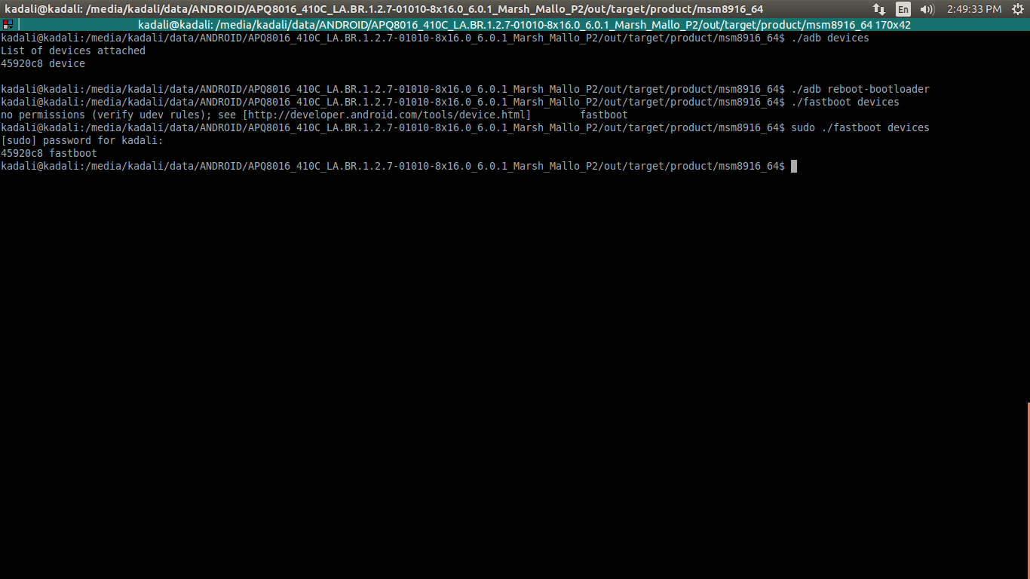

step4: flash the image using the script in the same path,where images are created.
The script file named (flash.sh) contains
./fastboot devices
./fastboot flash boot boot.img
./fastboot flash userdata userdata.img
./fastboot flash cache cache.img
./fastboot flash recovery recovery.img
./fastboot flash persist persist.img
./fastboot flash system system.img
./fastboot reboot

step5:After booting successfully run the commands to check it is booted or not
1)adb device
2)adb shell
3)su
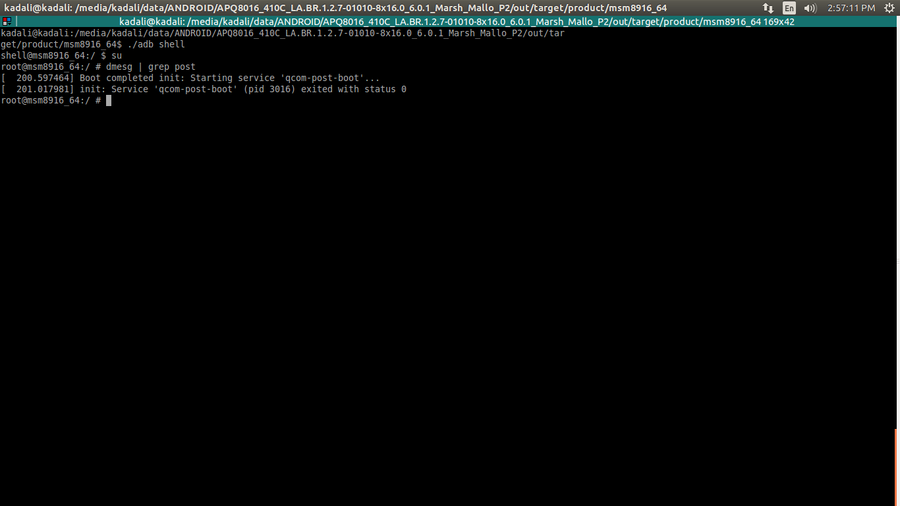
4)dmesg | grep post

THANK YOU
MOHAN

